**SLOW LEARNERS**

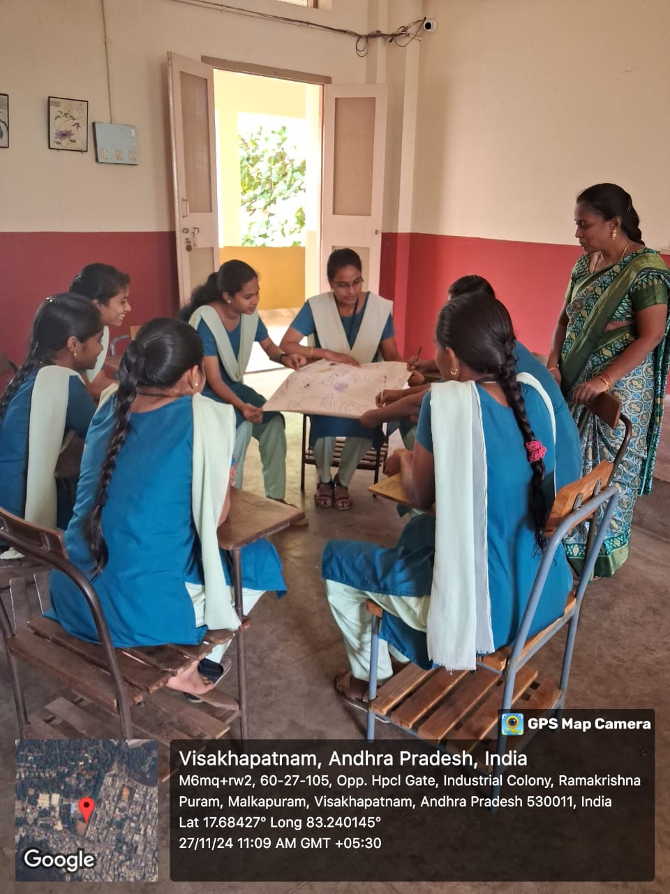 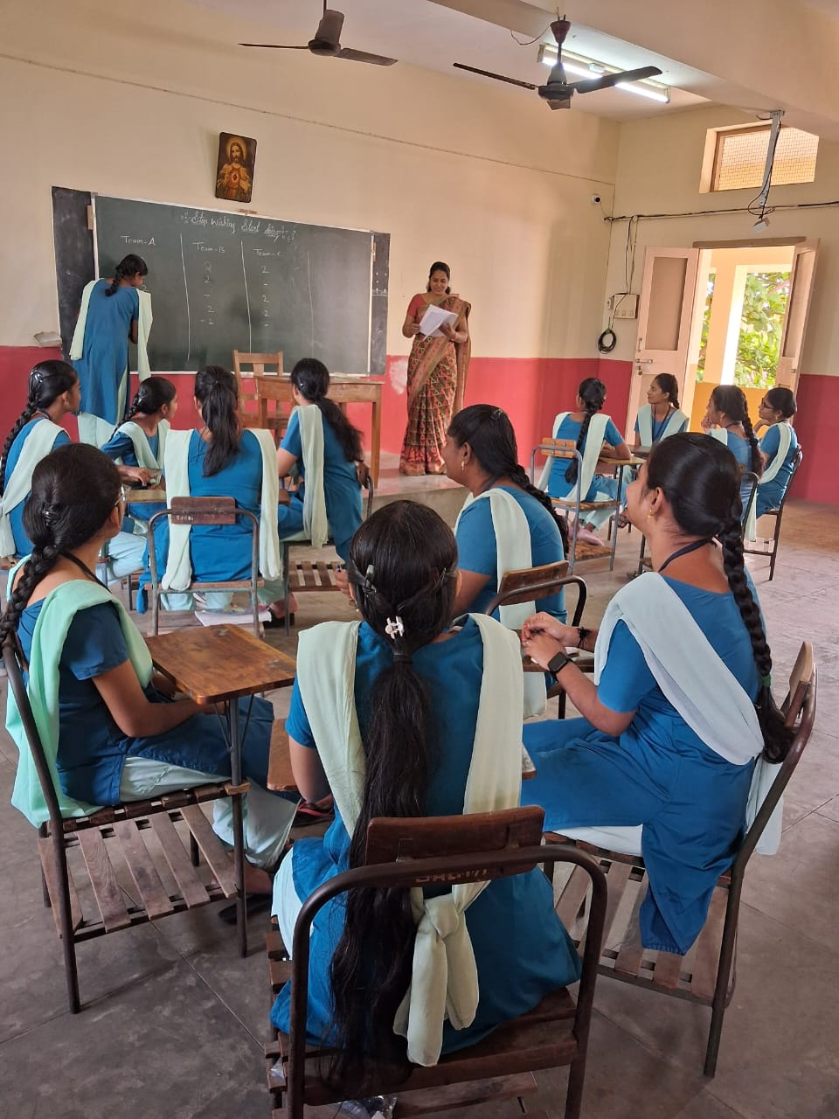

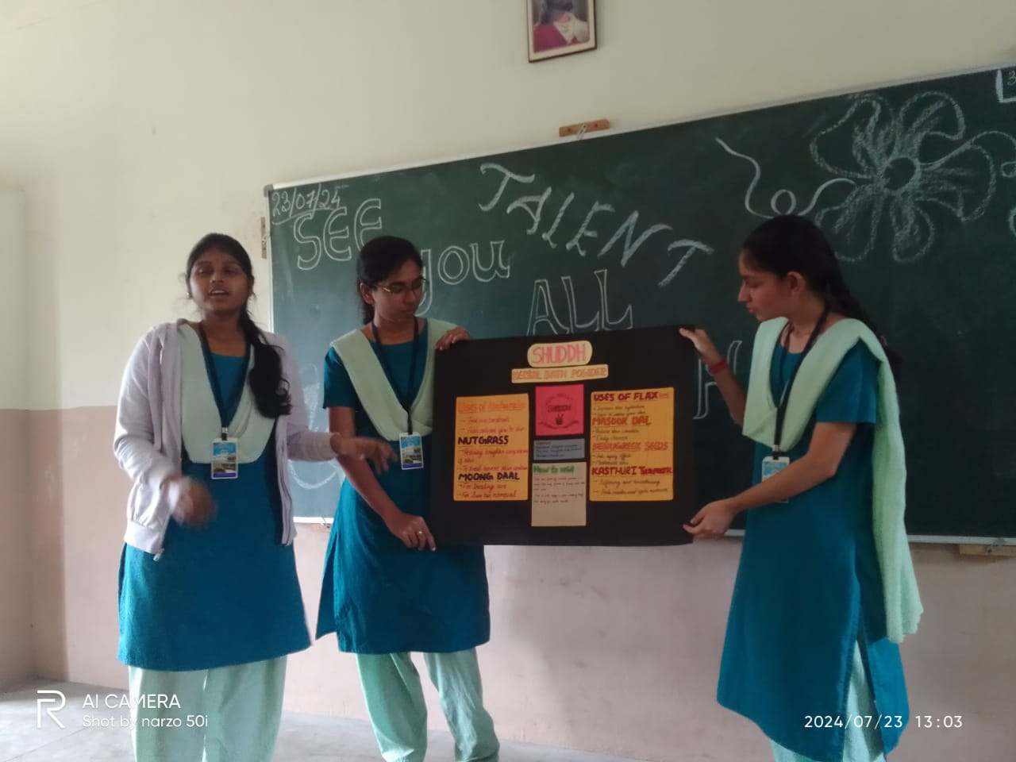

****

**ADVANCED LEARNERS**

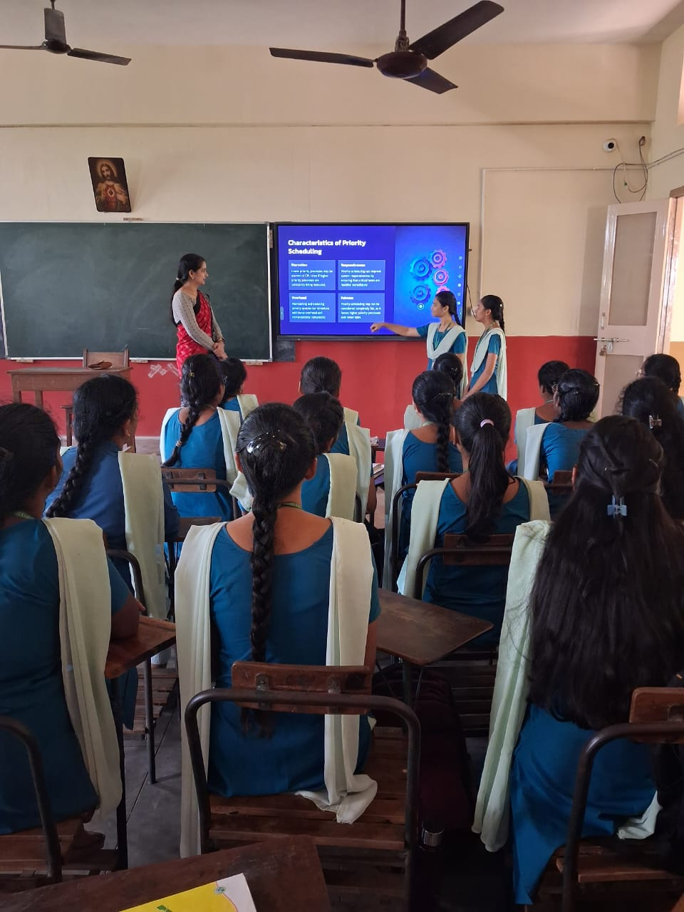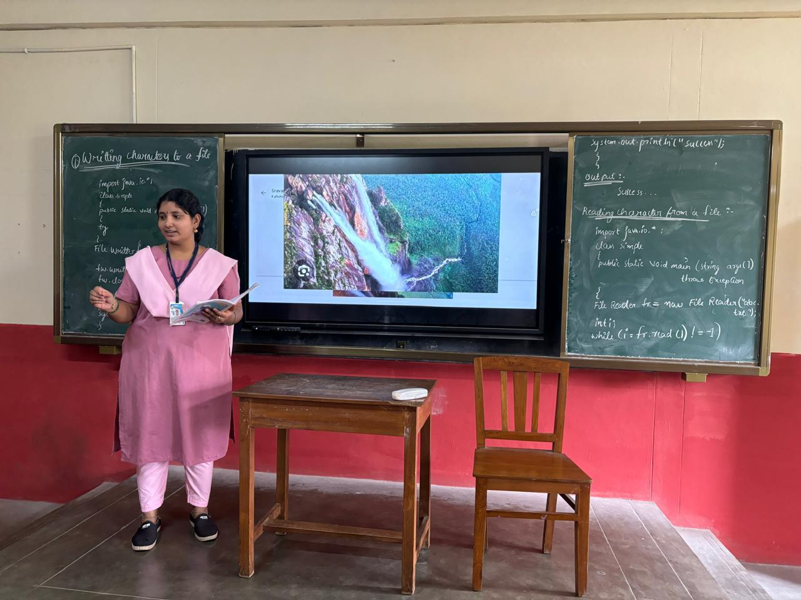

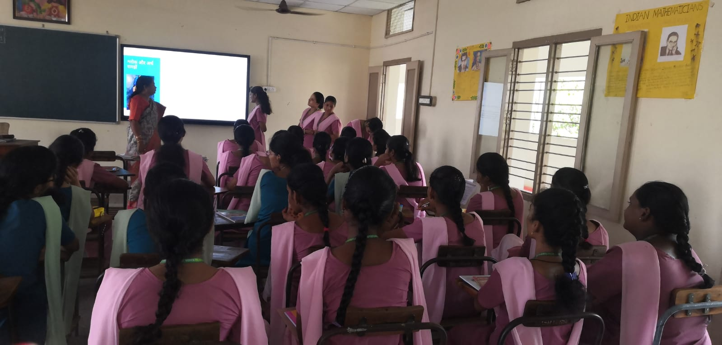



****

**ACTION METHODS REPORT**

**DEPARTMENT OF POLITICAL SCIENCE**

**LIST OF SLOW & ADVANCED LEARNERS**

**2023-24**

On the basis of the orientation programme & 1st unit test, the slow learners & Advanced learners are identified in the subjects of public administration..

The following students are identified as SLOW LEARNERS.

1. M.SARIKA-III BA

2. G.SIRI-III BA

3. B.ANJALI-II BA

4. D.MERCY-II BA

5. PAYAL BASAK-II BA

To improve their learning levels, the following ACTION TAKEN REPORT was prepared.

1] It is planned to conduct special classes for these students from 3.30 pm to 4.30 pm

2] Planned to Adopted Recitation method& role play method.

3] Planned to conduct Daily assignments & weekly tests.

Along these slow learners, the following ADVANCED LEARNERS also recognised. They are

1. A.ROJA-III BA

2. D.SIVANI-III BA

3. Y.DEBORE-II BA

4. PAYAL BASAK-II BA

5. V.SWETHA KUMARI-I BA

To sharpen their skill & satisfy them, the following ACTION TAKEN REPORT was prepared.

1] It is planned to give project work

2] Planned to give special coaching for different competitive exams

3] Planned to give opportunities for inter-collegiate elocution & essay writing competitions.

4] Planned to enhance their interest in the subject, survey method & audio –visual methods are adopted.

****

****

**DEPARTMENT OF SPECIAL ENGLISH**

**LIST OF SLOW & ADVANCED LEARNERS**

**2023-24**

On the basis of the orientation programme & 1st unit test, the slow learners & advanced learners are identified in the subjects of public administration.

The following students are identified as SLOW LEARNERS.

1. G.MONISHA-III BA

2. M.SARIKA-III BA

3. B.ANJALI-II BA

4. B.PRAMILA-II BA

5. E.MARCY-I BA

To improve their learning levels, the following ACTION TAKEN REPORT was prepared.

1] It is planned to conduct special classes for these students from 3.30 pm to 4.30 pm

2] Planned to Adopted Recitation method& role play method.

3] Planned to conduct Daily assignments & weekly tests.

Along these slow learners, the following ADVANCED LEARNERS also recognised. They are

1. A.NANDINI-III BA

2. P.ASVITHA-III BA

4. D.MERCY-II BA

5. T.ROOPIKA-BA

To sharpen their skill & satisfy them, the following ACTION TAKEN REPORT was prepared.

1] It is planned to give project work

2] Planned to give special coaching for different competitive exams

3] Planned to give opportunities for inter-collegiate elocution & essay writing competitions.

4] Planned to enhance their interest in the subject, survey method & audio –visual methods are adopted.



## HRDProf-2-9_merged_page-0001.jpg

## DEPARTMENT OF HISTORY

**LIST OF SLOW LEARNERS & ADVANCED LEARNERS**

**2023-24**

On the basis of the orientation programme & 1st unit test, the slow learners & Advanced learners are identified in the subjects of HISTORY.

The following students are identified as SLOW LEARNERS.

1. MONEESHA-IIIBA

2. M.SORIKA- III BA

3. PAYAL BASAK-II BA

4. SK.SULTANA BEGUM-II BA

5. B.ANJALI-II BA

To improve their learning levels, the following ACTION TAKEN REPORT was prepared.

1] It is planned to conduct special classes for these students from 3.30 pm to 4.30 pm

2] Planned to Adopted Recitation method& role play method.

3] Planned to conduct Daily assignments & weekly tests.

Along these slow learners, the following ADVANCED LEARNERS also recognized. They are

1. A.ROJA-III BA

2. G.HARSHITHA RANI-III BA

3. B.SRAVANTHI- II BA

4. E.KUSUMA-III BA

5. P.DIVYA SRI-II BA

To sharpen their skill & satisfy them, the following ACTION TAKEN REPORT was prepared.

1] It is planned to give project work

2] Planned to give special coaching for different competitive exams

3] Planned to give opportunities for inter-collegiate elocution & essay writing competitions.

4] Planned to enhance their interest in the subject, survey method & audio –visual methods are adopted.

****

**DEPARTMENT OF STATISTICS**

**LIST OF SLOW LEARNERS & ADVANCED LEARNERS**

**2023-24**

On the basis of the orientation programme & 1st unit test, the slow learners & advanced learners are identified in the subject of **STATISTICS**.

The following students are identified as **slow learners.**

1. G.MADHURI-III MSCS

2. M.MONIKA-III MSCS

3. P.MOUNIKA-II MSCS

4. M.ROJA-II MSCS

5. K.KAVYASRI-II MSCS

To improve their learning levels, the following **Action taken report** was prepared.

1. It is planned to conduct Special classes for these students from 4 to 5PM.
2. Planned to teach in the easy and understanding manner.
3. Planned to conduct Daily assignments & weekly tests.

Along with these slow learners, the following **Advanced learners** are also recognized. They are

1. A.DEVI-II MSCS

2. G.BAMAMANI-II MSCS

3. M.ROJA-IIMSCS

4. S.LAVANYA-III MSCS

5. SAI LAXMI-III MSCS

To sharpen their skills & satisfy them, the following **Action taken report** was prepared.

It is planned to provide extra work which provide extra knowledge.

1. It is planned to give team works.
2. Planned to give training for competitive exams and entrance exams.
3. Planned to give more opportunities to participate in inter-college activities and competitions.
4. It is planned to enhance their interest in their subject.

**DEPARTMENT OF PHYSICS**

**LIST OF SLOW LEARNERS & ADVANCED LEARNERS**

**2023-24**

On the basis of the orientation programme & 1st unit test, the slow learners & advanced learners are identified in the subject of PHYSICS. ­­­­

The following students are identified as slow learners

1. B.MEGHANA-III MPCS

2. D.BHAVANI-III MPCS

3. D.PALLAVI REDDY-II MPCS

4. G.LAVANYA-II MPCS

5. J.ANITHA-I MPCS

To improve their learning levels, the following Action taken report was prepared.

1. It is planned to conduct Special classes for these students from 3 to 5PM.
2. Planned to teach in easy and understanding manner.
3. Planned to conduct Daily assignments & weekly tests.

Along with these slow learners, the following Advanced learners are also recognized. They are

1. B.BAVANI- III MPCS

2. D.MERY SIRENI-III MPCS

3 .SHABNAM-II MPCS

4. D.SAI LAKSHMI-II MPCS

5. V.RAVEENA-I MPCS

To sharpen their skills & satisfy them, the following Action Taken Report was prepared.

1. It is planned to provide extra work which provide extra knowledge.

2. It is planned to team works.

3. Planned to give training for competitive exams and entrance exams.

4. Planned to give more opportunities to participate in inter-college activities and competition

5. It is planned to enhance their interest in their subject.

** DEPARTMENT OF MATHEMATICS**

**LIST OF SLOW LEARNERS & ADVANCED LEARNERS**

**2023-24**

On the basis of the orientation programme & 1st unit test, the slow learners & advanced learners are identified in the subject of MATHEMATICS**.**

The following students are identified as **slow learners**

1. P.BHARATHI-III MPCS

2. J.SHARMILA-III MPCS

3. GOWTHAMI SASMSL-III MSCS

4. A.S.M. DURGA BHAVANI-II MATHS

5. LOKITHA-II MATHS

To improve their learning levels, the following **Action taken report** was prepared.

1. It is planned to conduct Special classes for these students from 3 to 5PM.
2. Planned to teach in easy and understanding manner.
3. Planned to conduct Daily assignments & weekly tests.

Along with these slow learners, the following **Advanced learners** are also recognized. They are

1. D.SAI LAKSHMI-III MPCS

2. P.LIKITHA-III MPC

3 .M.YASHODA-III MSCS

4. T DEVI-II MATHS

5. MONEESHA-I MATHS

To Sharpen their skills & satisfy them, the following **Action taken report** was prepared.

1. It is planned to provide extra work which provide extra knowledge.
2. It is planned to give team works.
3. Planned to give training for competitive exams and entrance exams.

****

**Department of Chemistry**

**LIST OF SLOW LEARNERS & ADVANCED LEARNERS**

**2023-2024**

On the basis of the orientation programme and of their exams. The slow learners and advanced learners are identified in the subject of chemistry.

The following students are identified as slow Learners.

1. V.DEVI-III CBZ

2. D.SWAPNA-II MB

3. R.MAMATHA-II MB

4. G.BALAMANI-IIMB

5. MAHA LAKSHMI-II MPCS

To improve their learning levels the following action taken report was prepared.

1. Planned to conduct special/ extra classes for slow learners after the class hours on week days.
2. Planned to conduct basics of the subject were cleared through remedial classes.
3. Planned to give notes on important topics were provided for these students.
4. Planned to give presentations on theoretical portions for these students.
5. Planned to conduct oral test and daily test for these students.

Along with these slow learners, the following advanced learners are also recognized.

1. M.SAI DEEPTHI-III CBZ

2. S.TULASI-II CBZ

3. M.YASODA-III MSCS

4. Y.GAYATHRI-II MPCS

5. G.DIVYA-I Che

To Sharpen their skills and satisfy them the following action taken report was prepared.

1. Encourage to prepare for higher studies and participate in research pursuit.
2. Planned to conduct seminars on the advanced topic.
3. Encouraging to participate in various symposiums like quiz, poster presentation, conferences, inter institution competitions etc.
4. Planned to conduct training programs for gaining advanced technical know- how.
5. Planned to conduct internship projects field trip etc. For these students.

**Department of Botany**

**LIST OF SLOW LEARNERS & ADVANCED LEARNERS**

**2023-2024**

On the basis of the orientation programme and of their exams. The slow learners and advanced learners are identified in the subject of botany.

The following students are identified as slow Learners.

1. KHYATHI-III CBZ

2. JYOTHI-III CBZ

3. REVATHI-IICBZ

4. PAVANI-II CBZ

5. MOULIKA

To improve their learning levels the following action taken report was prepared.

1. Planned to conduct special/ extra classes for slow learners after the class hours on week days.
2. Planned to conduct basics of the subject were cleared through remedial classes.
3. Planned to give notes on important topics were provided for these students.
4. Planned to give presentations on theoretical portions for these students.
5. Planned to conduct oral test and daily test for these students.

Along with these slow learners, the following advanced learners are also recognized.

1 .S.RAJITHA-III CBZ

2. M.SAI DEEPTHI-III CBZ

3. D.PADMAVATHI-II CBZ

4. C.PAVANI-II CBZ

5. K.PARATHIMA SHARON

To Sharpen their skills and satisfy them the following action taken report was prepared.

* + - 1. Encourage to prepare for higher studies and participate in research pursuit.
      2. Planned to conduct seminars on the advanced topic.
      3. Encouraging to participate in various symposiums like quiz, poster presentation, conferences, inter institution competitions etc.
      4. Planned to conduct training programs for gaining advanced technical know- how.
      5. Planned to conduct internship projects field trip etc. for these students.

**Department of Zoology**

**LIST OF SLOW LEARNERS & ADVANCED LEARNERS**

**2023-2024**

On the basis of the orientation programme and of their exams. The slow learners and advanced learners are identified in the subject of zoology.

The following students are identified as slow Learners.

1. S.VYSHNAVI-III CBZ

2. Y.KAVITHA-III CBZ

3. P.SWAROOPA-II CBZ

4. D.PADMAVATHI-II CBZ

5. T.JASHNAVI

To improve their learning levels the following action taken report was prepared.

1. Planned to conduct special/ extra classes for slow learners after the class hours on week days.
2. Planned to conduct basics of the subject were cleared through remedial classes.
3. Planned to give notes on important topics were provided for these students.
4. Planned to give presentations on theoretical portions for these students.
5. Planned to conduct oral test and daily test for these students.

Along with these slow learners, the following advanced learners are also recognized.

1. HEMA SUDHA-III CBZ

2. I.JOTSHANA-III CBZ

3. R.SWAPNA SWAROOPA-II CBZ

4. K.NAVYASREE-II CBZ

5. G.APARNA-I CBZ

To Sharpen their skills and satisfy them the following action taken report was prepared.

1. Encourage to prepare for higher studies and participate in research pursuit.
2. Planned to conduct seminars on the advanced topic.
3. Encouraging to participate in various symposiums like quiz, poster presentation, conferences, inter institution competitions etc.
4. Planned to conduct training programs for gaining advanced technical know- how.
5. Planned to conduct internship projects field trip etc. For these students.

**Department of ENGLISH**

**LIST OF SLOW LEARNERS & ADVANCED LEARNERS**

**2023-24**

On the basis of the orientation program & 1st unit test, the slow learners & advanced learners are identified in the subject of **ENGLISH.**

The following students are identified as **slow learners**

1. B.TULASI LATHA-II MPCS

2. M.KUMAR-IIMPCS

3. M.ROJA-IIMSCS

4. P.MOUNIKA-II MSCS

5. K.KAVYASRI-II MSCS

To improve their learning levels, the following **Action taken report** was prepared.

1. It is planned to conduct Special classes for these students from 4pm to 5pm.
2. Planned to Adopted Recitation method, Role play & story telling method.
3. Planned to conduct Daily assignments & weekly tests.

Along with these slow learners, the following **Advanced learners** are also recognized. They are

1. B.NAVYA SREE-II MPCS

2 .N.MANJU-II MSCS

3. R.NAVYA-II BA

4. AYESHA SIDDI III B.COM

5. S.P.MANI DEEPIKA-II MB

To Sharpen their skills & satisfy them, the following **Action taken report** was prepared

1. It is planned to give project work.
2. Planned to select their names to lead the seminars and participate in workshops.
3. Planned to give special coaching for competitive examinations.
4. Planned to give opportunities for inter- collegiate elocution & essay writing competitions.
5. Planned to enhance their interest in the subject, survey method, project method & audio-visual methods are adopted.

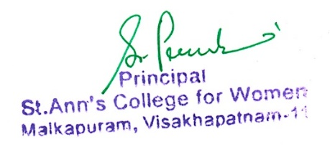

## HRDProf-2-9_merged_page-0001.jpgDEPARTMENT OF COMPUTER SCIENCE

**LIST OF SLOW LEARNERS & ADVANCED LEARNERS**

**2023-24**

On the basis of the orientation programme & 1st unit test, the slow learners & Advanced learners are identified in the subjects of COMPUTER SCIENCE.

The following students are identified as SLOW LEARNERS.

1 .M.MONIKA-III MSCS

2. G.MADHURI-III MSCS

3. D.BHARATHI-II MPCS

4. G.LAVANYA-II MPCS

5. K.DURGA BHAVANI-I BSC

To improve their learning levels, the following ACTION TAKEN REPORT was prepared.

1] It is planned to conduct special classes for these students from 3.30 pm to 4.30 pm

2] Planned to Adopted Recitation method& role play method.

3] Planned to conduct Daily assignments & weekly tests.

Along these slow learners, the following ADVANCED LEARNERS also recognised. They are

1 .A.DEEPIKA-III MSCS

2. S.LAVANYA-III MPCS

3 .L.MAHALAKSHMI-II MPCS

4. B.TULASI LATHA-II MPCS

5. D.VASANTHI-I CS

To sharpen their skill & satisfy them, the following ACTION TAKEN REPORT was prepared.

1] It is planned to give project work

2] Planned to give special coaching for different competitive exams

3] Planned to give opportunities for inter-collegiate elocution & essay writing competitions.

4] Planned to enhance their interest in the subject, survey method & audio –visual methods

.

**DEPARTMENT OF TELUGU**

**LIST OF SLOW LEARNERS & ADVANCED LEARNERS**

**2023-2024**

On the basis of the orientation programme &1st unit test, the slow learners and advanced learners are identified in the subject of Telugu.

The following students are identified as slow learners

1. B.TULASI LATHA-II MPCS

2. R.NEERAJA-II MSCS

3. M.ESWARI -II BBA

4. M.ASHA-II BA

5. K.CHANDINI-II MB

To improve their learning levels, the following action taken report was prepared.

1. It is planned to conduct special classes for these students from 3 to 5 pm

2. Planned to reach in easy and understanding manner.

3. Planned to conduct daily assignments &weekly tests.

Along with these slow learners, the following Advanced learners also recognized. They are:

1. A.PAIDI TALLI-II MPCS

2. M.YASODHA-II MSCS

3. CH.RAMYA-II BBA

4. P.DIVYA SREE-II BA

5. S.GOWTHAMI-II BA

**To sharpen their skills & satisfy them, the following action taken report was prepared.**

1. It is planned to provide extra work which provide extra knowledge.

2. it is planned to team works.

3. planned to give training for competitive exams and entrance exams.

4.planned to give more opportunities to participate in inter -college activities and competitions.

5.it is planned to enhance their interest in their subject.

## HRDProf-2-9_merged_page-0001.jpgDEPARTMENT OF COMMERCE

**LIST OF SLOW LEARNERS & ADVANCED LEARNERS**

**2023-24**

On the basis of the orientation programme & 1st unit test, the slow learners & Advanced learners are identified in the subjects of COMMERCE.

The following students are identified as SLOW LEARNERS.

1. M.SAI VARSHITHA-III BBA

2. CH.RENUKA-III B.COM

3. B.VENKATA ALEKHYA-III B.COM

4. C.H. KAVYA AMRUTHA-I BBA

5. Y.PAVANI-I BA

To improve their learning levels, the following ACTION TAKEN REPORT was prepared.

1] It is planned to conduct special classes for these students from 3.30 pm to 4.30 pm

2] Planned to Adopted Recitation method& role play method.

3] Planned to conduct Daily assignments & weekly tests.

Along these slow learners, the following ADVANCED LEARNERS also recognised. They are

1. K.ALEKHYA-III B.COM

2. S.BHARATHI-III BBA

3. SK.SALMA-II B.COM

4. SATYA SWETHA-I B.COB

5. VARISHTA-I BBA

To sharpen their skill & satisfy them, the following ACTION TAKEN REPORT was prepared.

1] It is planned to give project work

2] Planned to give special coaching for different competitive exams

3] Planned to give opportunities for inter-collegiate elocution & essay writing competitions.

4] Planned to enhance their interest in the subject, survey method & audio –visual methods are adopted.



**DEPARTMENT OF HINDI**

**LIST OF SLOW LEARNERS & ADVANCED LEARNERS**

**2023-24**

On the basis of the orientation programme & 1st unit test, the slow learners & Advanced learners are identified in the subjects of HINDI.

The following students are identified as SLOW LEARNERS.

1. B.TULASI LATHA-II MPCS

2. M.KUMAR-IIMPCS

3. M.ROJA-IIMSCS

4. P.MOUNIKA-II MSCS

5. K.KAVYASRI-II MSCS

To improve their learning levels, the following ACTION TAKEN REPORT was prepared.

1] It is planned to conduct special classes for these students from 3.30 pm to 4.30 pm

2] Planned to Adopted Recitation method& role play method.

3] Planned to conduct Daily assignments & weekly tests.

Along these slow learners, the following ADVANCED LEARNERS also recognised. They are

1. B.NAVYA SREE-II MPCS

2. N.MANJU-II MSCS

3. R.NAVYA-II BA

4. AYESHA SIDDI

5. S.P.MANI DEEPIKA-II MB

To sharpen their skill & satisfy them, the following ACTION TAKEN REPORT was prepared.

1] It is planned to give project work

2] Planned to give special coaching for different competitive exams

3] Planned to give opportunities for inter-collegiate elocution & essay writing competitions.

4] Planned to enhance their interest in the subject, survey method & audio –visual methods are adopted.



**Department of Micro Biology**

**LIST OF SLOW LEARNERS & ADVANCED LEARNERS**

**2023-2024**

On the basis of the orientation programme and of their exams. The slow learners and advanced learners are identified in the subject of Micro Biology.

The following students are identified as slow Learners.

1. K.CHANDINI-III MB

2. VINEELA-III MB

3. LAHARI-II MB

4. ROHINI-II MB

5. JYOTHI-IIMB

To improve their learning levels the following action taken report was prepared.

* + - 1. Planned to conduct special/ extra classes for slow learners after the class hours on week days.
      2. Planned to conduct basics of the subject were cleared through remedial classes.
      3. Planned to give notes on important topics were provided for these students.
      4. Planned to give presentations on theoretical portions for these students.
      5. Planned to conduct oral test and daily test for these students.

Along with these slow learners, the following advanced learners are also recognized.

1. VJUVALA-II MB

2. YAMINI-II MB

3. DHANA-II MB

4. SANTHISHI- III MB

5. JASMINE-III MB

To Sharpen their skills and satisfy them the following action taken report was prepared.

Encourage to prepare for higher studies and participate in research pursuit.

Planned to conduct seminars on the advanced topic.

Encouraging to participate in various symposiums like quiz, poster presentation, conferences, inter institution competitions etc.

Planned to conduct training programs for gaining advanced technical know- how.

Planned to conduct internship projects field trip etc. for these students.