

DATE: 16-7-2023

**TO WHOM IT MAY CONCERN**

This is to certify that the Governing Body of St. Ann’s College for Women has sanctioned the teachers for various programmes in the academic year 2023-2024.

|  |  |  |
| --- | --- | --- |
| **FACULTY** | **DEPARTMENT** | **NUMBER OF SANCTIONED POSTS** |
| FACULTY OF SOCIAL SCIENCES | HISTORY | 1 POST |
| POLITICAL SCIENCE | 2 POSTS |
| ECONOMICS | 1 POST |
| FACULTY OF HUMANITIES | HINDI | 1 POST |
| ENGLISH | 3 POSTS |
| TELUGU | 1 POST |
| FACULTY OF SCIENCE | BOTANY | 2 POSTS |
| ZOOLOGY | 2 POSTS |
| PHYSICS | 1 POST |
| CHEMISTRY | 2 POSTS |
| MATHS | 3 POSTS |
| STATISTICS | 1 POST |
| MICROBIOLOGY | 1 POST |
| BIOCHEMISTRY & BIOTECHNOLOGY | 1 POST |
| FACULTY OF COMPUTERS | COMPUTERS | 6 POSTS |
| FACULTY OF COMMERCE | ACCOUNTS | 8 POSTS |
| LIBRARIAN | LIBRARY | 1 POST |
| PHYSICAL DIRECTRESS | SPORTS | 1 POST |
| **TOTAL** |  | **38 POSTS** |

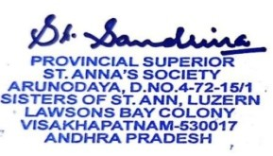

**PRESIDENT**



**TO WHOM IT MAY CONCERN**

This document certifies the compilation of faculty members arranged department-wise, aligning with the sanctioned positions for the academic year 2023-2024.

**LIST OF FACULTY DEPARTMENT-WISE 2023-2024**

|  |  |  |
| --- | --- | --- |
| **DEPARTMENT** | **SUBJECT** | **NAME OF THE FACULTY** |
| SOCIAL SCIENCES | HISTORY | MRS. LALITHA G |
| POLITICAL SCIENCE | MISS. BHAGYALAKSHMI EPS |
| MISS. ANASUYA DEVI Y |
| ECONOMICS | MR. B. P. RAJU |
| HUMANITIES | HINDI | MRS. ADILAKSHMI |
| ENGLISH | MRS. A. ROJA |
| MISS JOSHNA JAISY |
| MRS. ABIDA BEGUM |
| TELUGU | MRS. V. LAKSHMI DEVI |
| SCIENCE | BOTANY | Dr. Sr. PREMA KUMARI J. |
| Dr. MRS. G. ADISHESHU |
| ZOOLOGY | MRS. S. LAKSHMI TULASI |
| MRS. BINDU SREE LAKSHMI |
| PHYSICS | MRS. K. TRIVENI |
| CHEMISTRY | MISS SK. VALISHA |
| MRS. ANJALI DEVI |
| MATHS | MRS. VENKATA LAKSHMI |
| MISS MANJULA |
| MRS. K. SUNEETHA |
| STATISTICS | MRS M. ANUSHA |
| MICROBIOLOGY | MRS. PRASANTHI |
| BIOCHEMISTRY & BIOTECHNOLOGY | MRS. SUDHA RANI M |
| COMPUTERS | COMPUTERS | MRS. A. SHANTI RANI |
| MISS SHARINA TOOR |
| MRS. S.MAHA LAKSHMI |
| MR. MANU |
| MRS. D. RAJA KUMARI |
| MR. MURALI |
| COMMERCE | ACCOUNTS | MRS. P. LAVANYA |
| MR. V. V. BALAKRISHNA |
| MRS. B. SANTHI |
| MISS. A. DIVYA JYOTHI |
| MRS. P. JAYASRI |
| MRS. M. RENUKA |
| MISS REBIKHA FRANCIS |
| MRS. M. ALEKHYA |
| LIBRARY | LIBRARY | MRS. G. SIRISHA |
| SPORTS | PHYSICAL DIRECTRESS | MRS. SANDHYA RANI |





DATE: 25-5-2023

Note Submitted to Manager/President

This is to bring to your kind notice that the academic year 2023-24 is going to commence from 05-06-2023. To meet the statutory requirement of staff to student ratio of 1:19 and also to fill the vacant positions, we need to recruit at-least 4 more teaching staff members. Hence permission may be accorded to sanction 4 more post and to call for the teaching staff recruitment at this institution in specialization in Computers (2), Zoology, Mathematics, Job oriented at a cadre of Professor/Associate Professor/Assistant Professor/Lecturer/Teacher. Kindly permit us to proceed with teaching staff recruitment process for academic year 2023-24.



**PRINCIPAL**

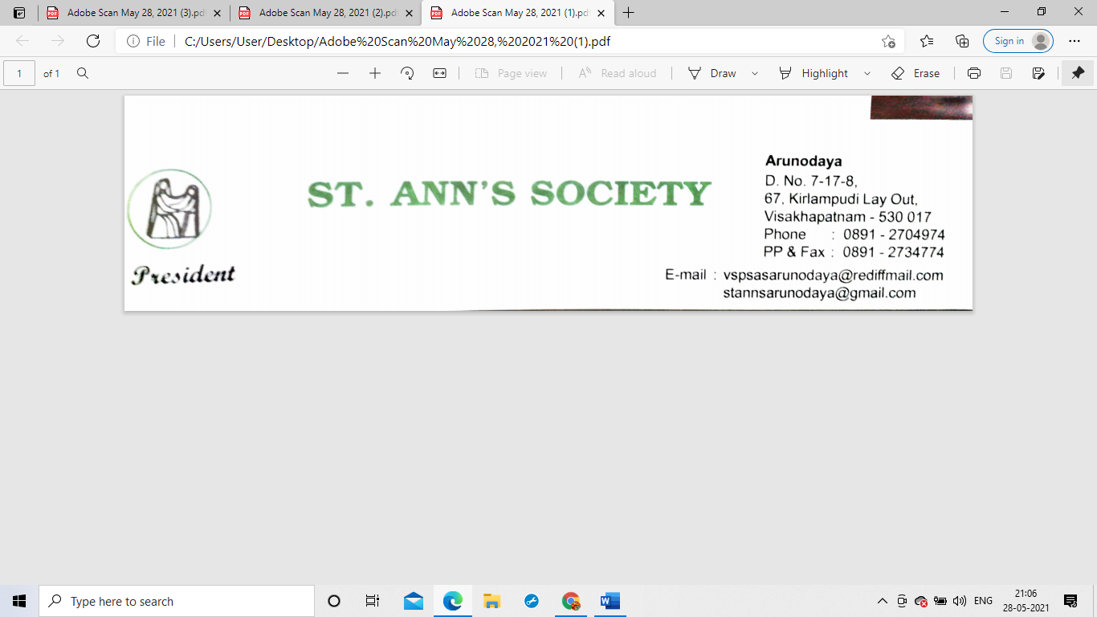

DATE: 26-6-2023

**Approval of Sanctioning of Posts**

On the recommendation of your selection committee dated on -10-06-2023mof the St. Ann’s College for Women and with the approval of the Secretary, I as the Manager/President of St. Ann’s Society Visakhapatnam Province sanction the following post for St. Ann’s College for Women, Visakhapatnam. Furthermore you are to follow up the necessary matters with the University.

|  |  |  |
| --- | --- | --- |
| **SNO** | **DEPARTMENT** | **NAME OF THE FACULTY** |
| **01** | ZOOLOGY | MRS. BINDU SREE LAKSHMI |
| **02** | COMPUTERS | MRS. D. RAJA KUMARI |
| **03** | COMPUTERS | MRS. S.MAHA LAKSHMI |
| **04** | MATHS | MRS. K. SUNEETHA |

